|  |  |
| --- | --- |
|  | **Office of the Chief Economist** |

**Government Interest Patents:   
When Public Investment Feeds Innovation**

**Sanjay K. Arora, Amanda Myers, and Andrew A. Toole**

**OCE Data Brief Number 2, March 2018**

This data brief examines the flow of patented inventions emerging from federally funded research and development (R&D) expenditures between 1980 and 2016. The analysis is made possible by the newly incorporated “government interest statement” data in PatentsView ([www.patentsview.org)](http://www.patentsview.org)), a web-based data visualization and analysis platform supported by United States Patent and Trademark (USPTO) Office of the Chief Economist (OCE).

**Overview of Key Findings**

1. Patented inventions funded by federal research programs have experienced strong growth in the past decade, [slightly] outpacing increases in overall patenting even as total Federal R&D expenditure has declined.
2. Federal agencies fund patented inventions output developed at universities and corporations in differing but overall increasing amounts
3. Small firm entrants into patenting have increased more than five-fold since 1990
4. Inventions from Federally-supported R&D involve larger inventor teams, and women are increasingly likely to participate
5. University and corporate assigned government interest patents appear more economically valuable than patents assigned to the government

**Introduction**

The Bayh-Dole Act of 1980 stands as a landmark piece of legislation: it created a uniform patent policy among federal agencies, enabling firms, non-profit organizations, and universities to retain title to inventions developed through federally funded research.[1] It is credited with stimulating innovation, enhancing the commercial potential of research, and helping to create new products, startups, and jobs. .

Before passage of the Bayh-Dole Act, title to innovations developed with federal funds often remained with the government, and agencies had inconsistent policies regarding licensing and use of technologies by firms and entrepreneurs. One major objective of legislation was to encourage the transfer of technology from lab to market and improve economic and innovation outcomes. Universities, in particular, benefit because they are able to retain rights to inventions funded by federal dollars and subsequently license those technologies to spinoffs and other firms. Small firms, through funding programs such as Small Business Innovation Research (SBIR) and Small Business Technology Transfer (STTR), too, can better leverage inventions supported by federal R&D funding to grow their businesses.

Importantly, to retain title under the Bayh-Dole Act, an entity must, among other obligations, timely file a US patent application with the USPTO in which they disclose a “government interest” in their invention. Generally, a “government interest statement” specifies that the invention was funded – at least in part – by a federal research grant or procurement contract.[2] While often overlooked, the government interest statement provides an explicit paper trail to track inventions flowing from federal research dollars. This issue brief examines the granted patents that contain such government interest statements (hereafter “government interest patents”) and explores their growth in the near forty years since enactment of Bayh-Dole.

The analysis is utilize government interest statement data from PatentsView ([www.patentsview.org)](http://www.patentsview.org)), a web-based data visualization and analysis platform supported by United States Patent and Trademark (USPTO) Office of the Chief Economist (OCE). Government interest statements appear as plain text on the face of a patent grant document. As part of the PatentsView data processing pipeline, this raw text is parsed to identify government organizations, such as the Department of Defense and the National Institutes of Health (NIH). These organizations are then organized in a hierarchy reflecting the current structure of the government; for example, NIH currently falls under the Department of Health and Human Services (DHHS). Details on the data and method may be found in Appendix A.

**Patented Inventions from Federally-Supported R&D Show Strong Growth in Recent Years**

Figure 1 depicts trends in federal funding of R&D, overall patenting, and government interest patents for the 1980-2017 period. To enable visual comparison of the trends, Figure 1 shows the index value, normalized to 100 for each series in 1980 (see Appendix B for actual values).

The U.S. Government funds approximately $150 billion in R&D each year, but that figure has fluctuated over time. Real federal funding on R&D climbed through the late 2000s, peaking in 2010 with the large incremental increase authorized by the American Recovery and Reinvestment Act of 2009 (ARRA). Since 2010, however, total real federal R&D funding has largely declined (Figure 1, dashed green line).[3]

In contrast, the number of government interest patents (solid cyan line) has surged, outpacing growth in total patenting. Over the past decade, the number of government interest patents granted has doubled, climbing from around 3,600 in the late 2000s to more than 7,200 in 2017 (roughly 7.1% per year 2008-2017). As Figure 1 shows, the total number of patent grants has also grown over this period but at a slightly slower pace (about 6.6% per year 2008-2017). Accordingly, the share of total patents with a government interest climbed from 1.9% in 2008 to 2.2% in 2013 but fell back down to 2.1% in 2017.

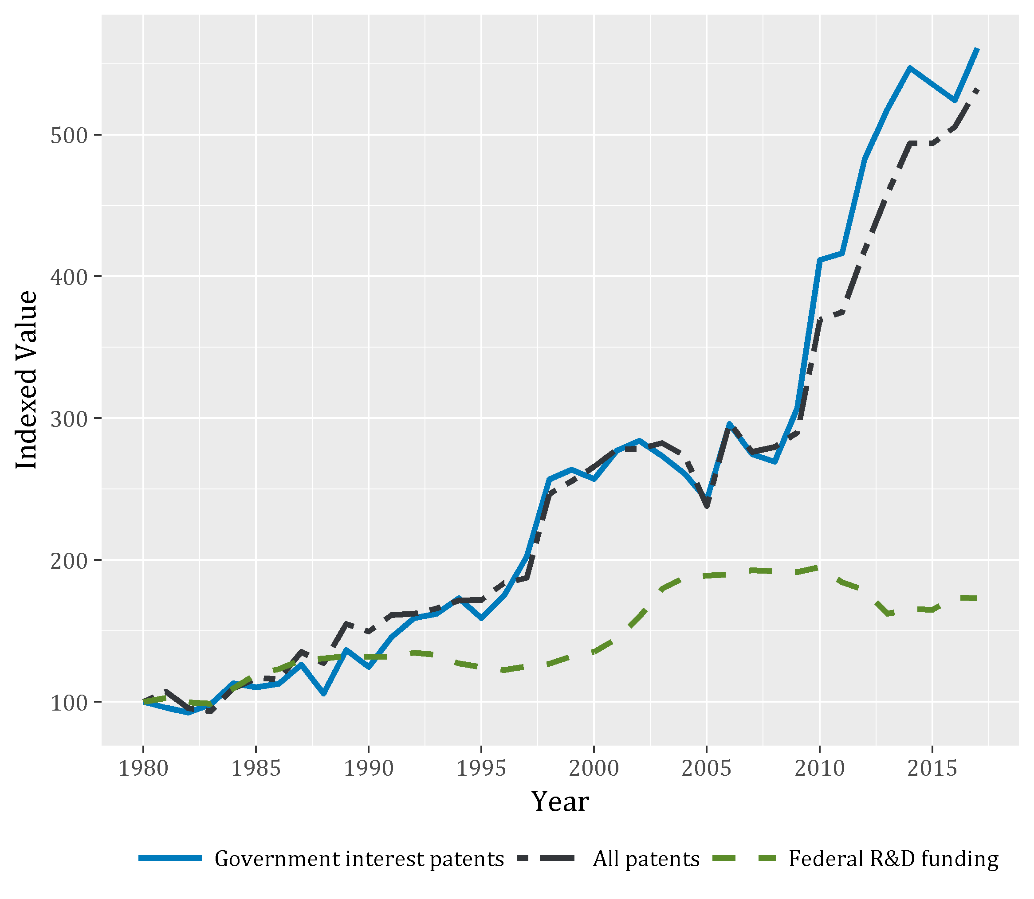

**Figure 1**: Growth in government interest, all patents, and real Federal R&D funding, indexed at 1980 levels (federal R&D funding estimated for 2016 and 2017 based on President’s request)[4]

Generally, R&D dollars are invested well before an innovation emerges and several years before that invention is patented. Thus, patent grants would tend to lag R&D expenditure. Accordingly, Figure 1 shows the strongest growth in government interest patents occurring in the five years following ARRA. This does not necessarily mean that ARRA, or the prior years of relatively high funding, drove this growth in government interest patents, especially given the fact that total patenting also grew at a rapid pace during this time. However, the relationship between ARRA stimulus and the subsequent surge in government interest patents warrants further investigation.

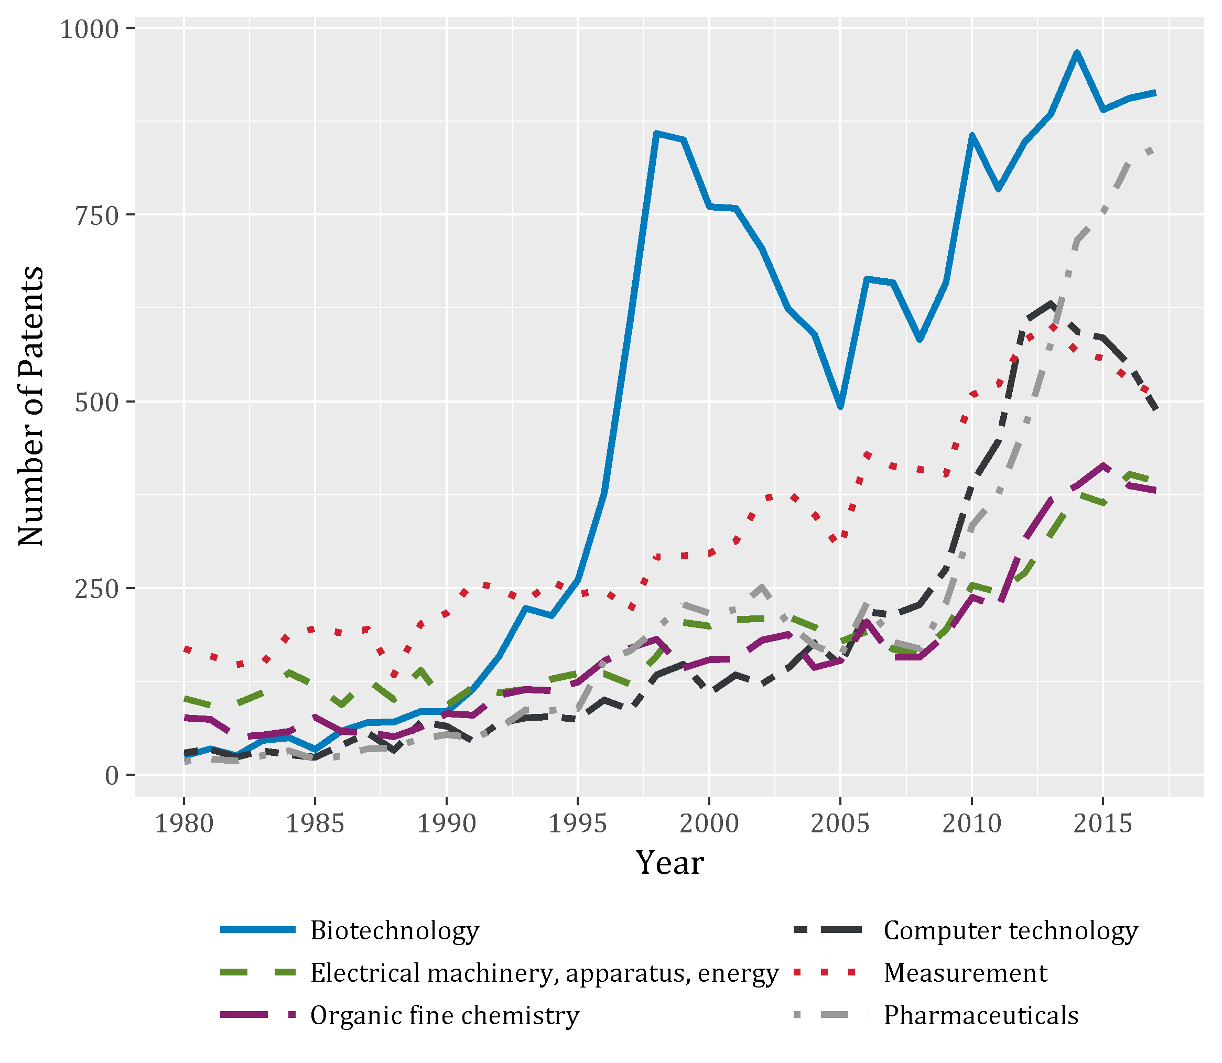

**Figure 2**: Government interest patents granted 1980-2017, top six technology fields

Government interest patenting is dispersed across a wide variety of technology areas. Figure 2 shows trends in the number of government interest patents for the top six technology fields. These six fields account for less than half (47%) of all government interest patents issued 1980-2017.[5] Historically, the largest share of government interest patents involve biotechnology (14.0% of government interest patent granted 2008-2017). However, in the last decade, government funding has support more patenting in pharmaceuticals (8.9% of government interest patent granted 2008-2017), measurements (8.7%), and computer technology (8.1%).

Government interest patenting has grown over time across nearly all technologies areas. In some fields, this growth largely matches increases in overall patenting, but, in other areas, growth in government-supported patents is outpacing the overall trends. Figure 3 depicts the share of total patent grants with a government interest for the same top six technology fields shown in Figure 2. [Limit to patents granted 2005-2017 when most of the growth in government interest and overall patenting occurs (see Figure 1).]

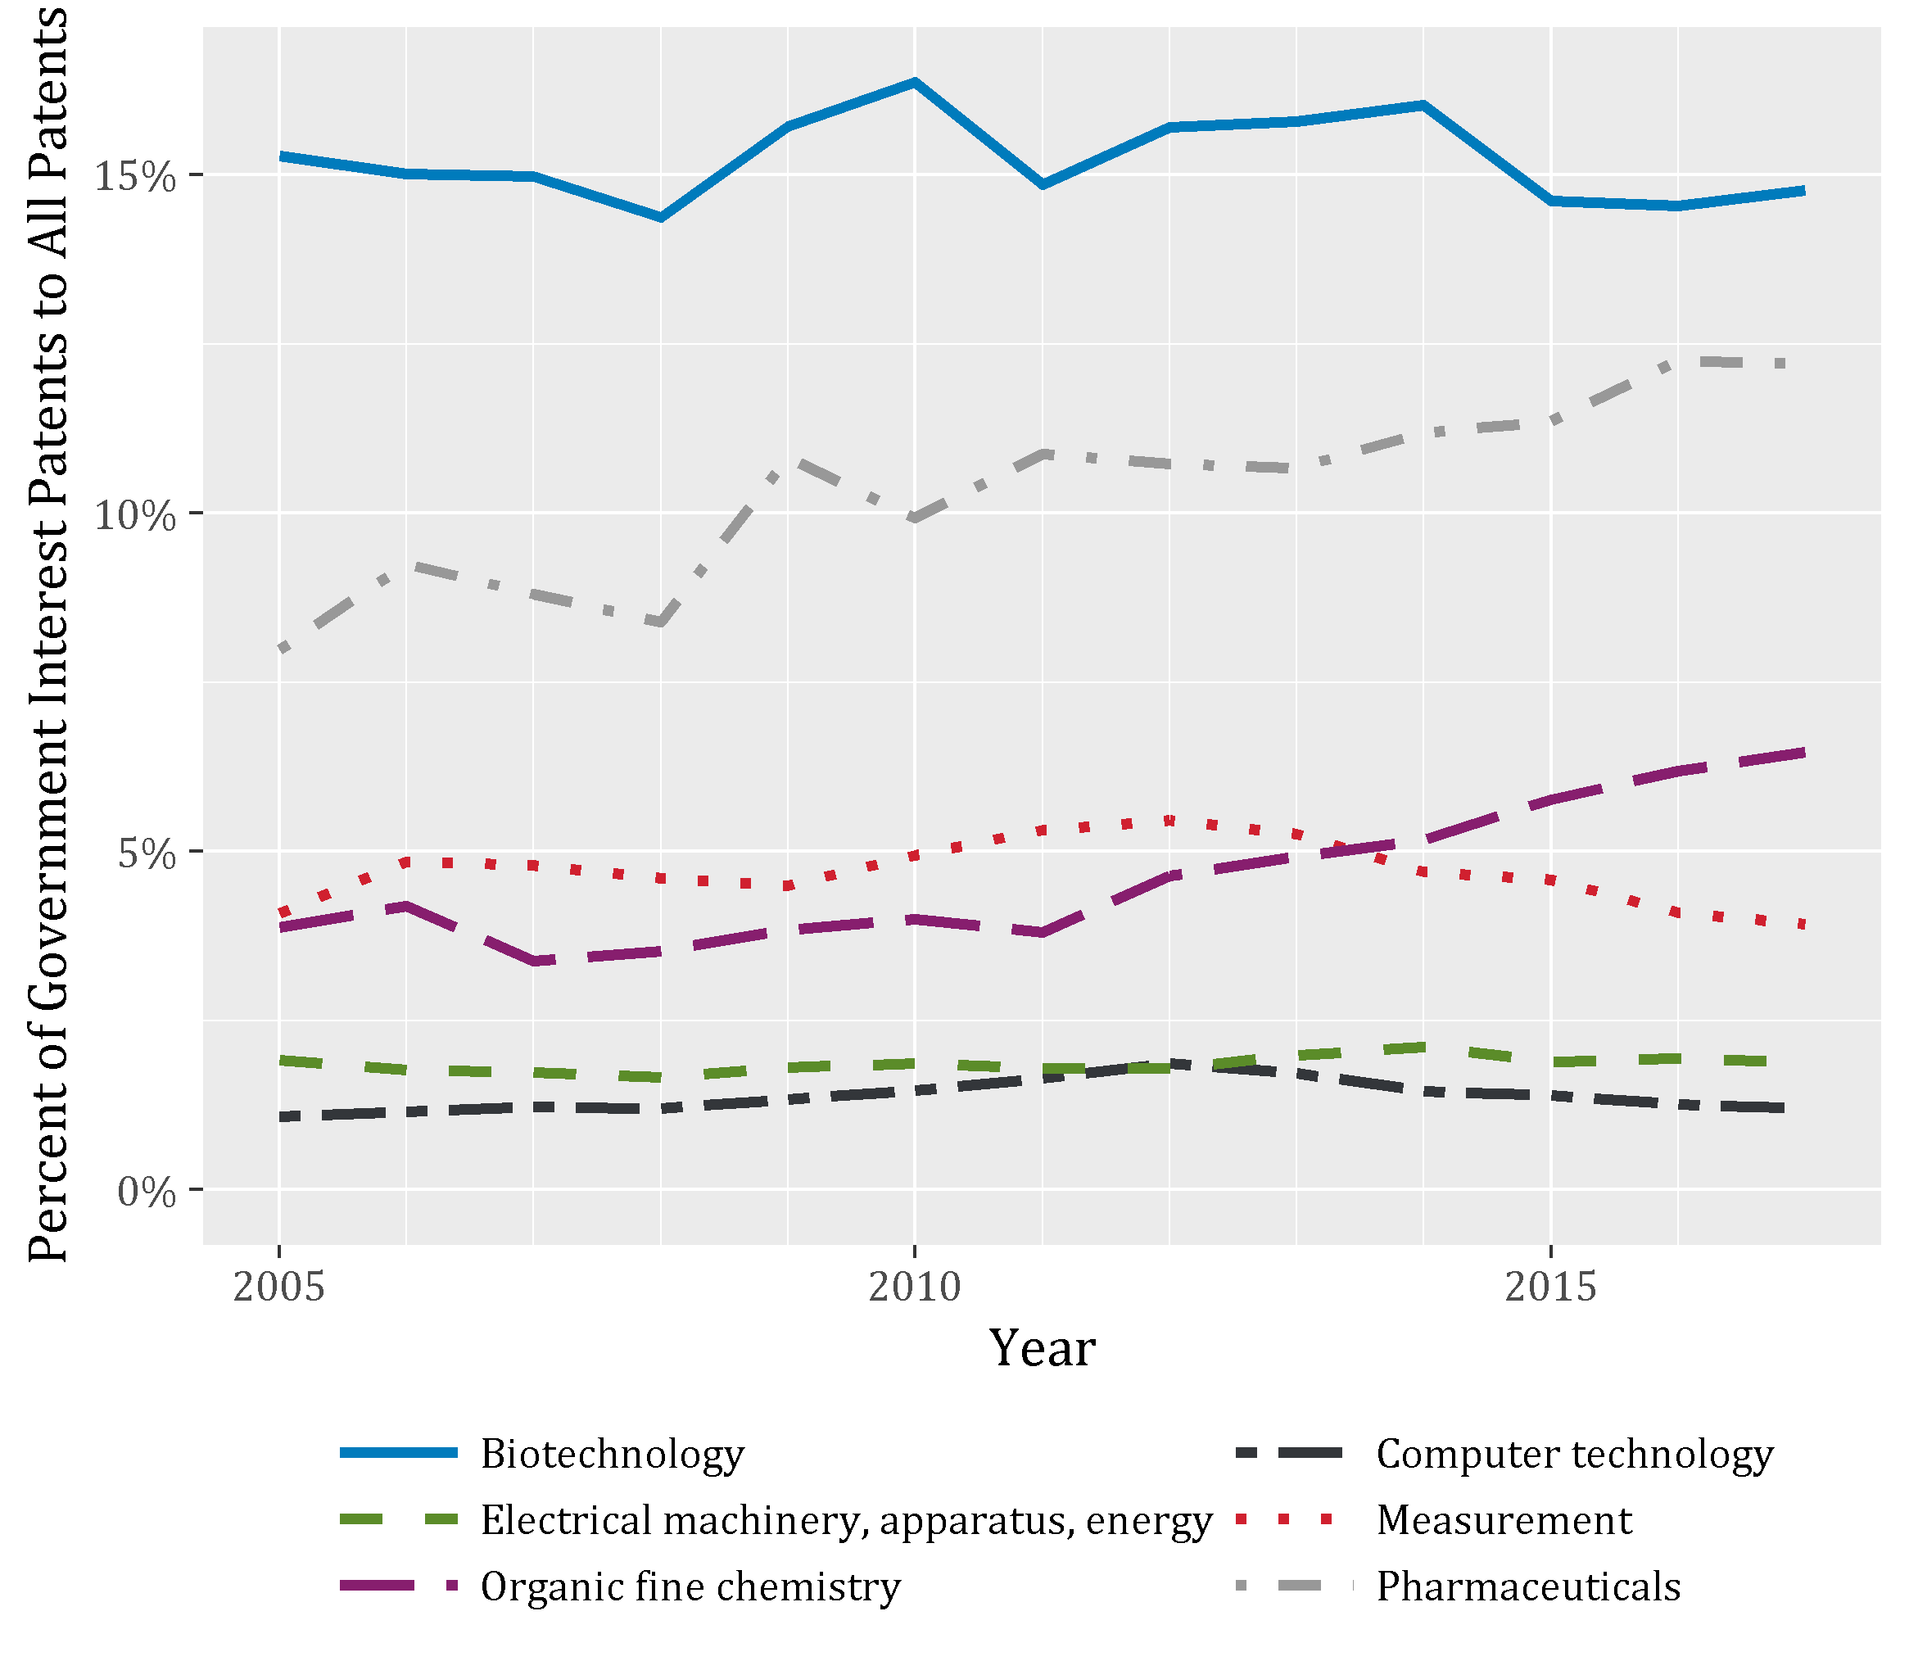

**Figure 3:** Share of total patents with a government interest 2005-2017, top six technology fields

As Figure 3 shows, government-supported patents account for a sizeable share, roughly 15%, of all biotechnology patents. However, the share of biotechnology patents with a government interest has held relatively constant from 2005 through 2017, indicating that growth in biotechnology government interest patents has largely kept pace with overall patenting in that field. By contrast, the share of pharmaceutical and organic fine chemistry patents with a government interest has increased. Government-supported patents comprised about 8.0% of all pharmaceutical patents in 2005. This percentage climbed to 12.2% in 2017. Likewise, the share of organic fine chemistry patents with a government interest rose from 3.9% to 6.5% over the same period. The factors driving this increasing intensity of government-supported patents in pharmaceutical and organic fine chemistry are unclear and merit further study.

**Government Interest Patents Are Concentrated among a Small Set of Funding Agencies but Dispersed across Sectors**

The federal R&D landscape, as measured by both R&D dollar inputs and government interest patents, is concentrated among a small set of US Federal Departments and Agencies.[6] Figure 4 depicts the number of government interest patents for the top high-level agencies[7]: Department of Health and Human Services (DHHS), Department of Defense (DOD), Department of Energy (DOE), National Science Foundation (NSF), and National Aeronautics and Space Administration (NASA). Together, these five agencies accounted for about 75% of government interest patents granted in 2017 (and roughly 93% of total federal R&D spending in 2015).[8] Historically, DHHS, largely through the National Institutes of Health (NIH) programs, has supported the most government interest patents granted each year.[9] More recently, however, a growing share of government interest patents are emerging from DOD, and to some extent NSF, funding. Among government interest patents granted in 2017, DHHS supported roughly 32%, DOD 18%, and NSF 12%. DOE supplied funding for 11% of government interest patents granted in 2017, down from previous grant years when roughly 17% of such patents were DOE-supported.[10]

While only a few agencies supply most of the funding that supports government interest patenting, the recipients of those investments are dispersed across sectors. For each agency, Figure 4 shows the number of government interest patents broken out by the type of “assignee”, that is the entity to which the patent was issued and presumably the recipient of the federal R&D funds. First, note that each one of the top funding agencies has supported patents assigned to both academic and corporate entities, though to varying degrees.

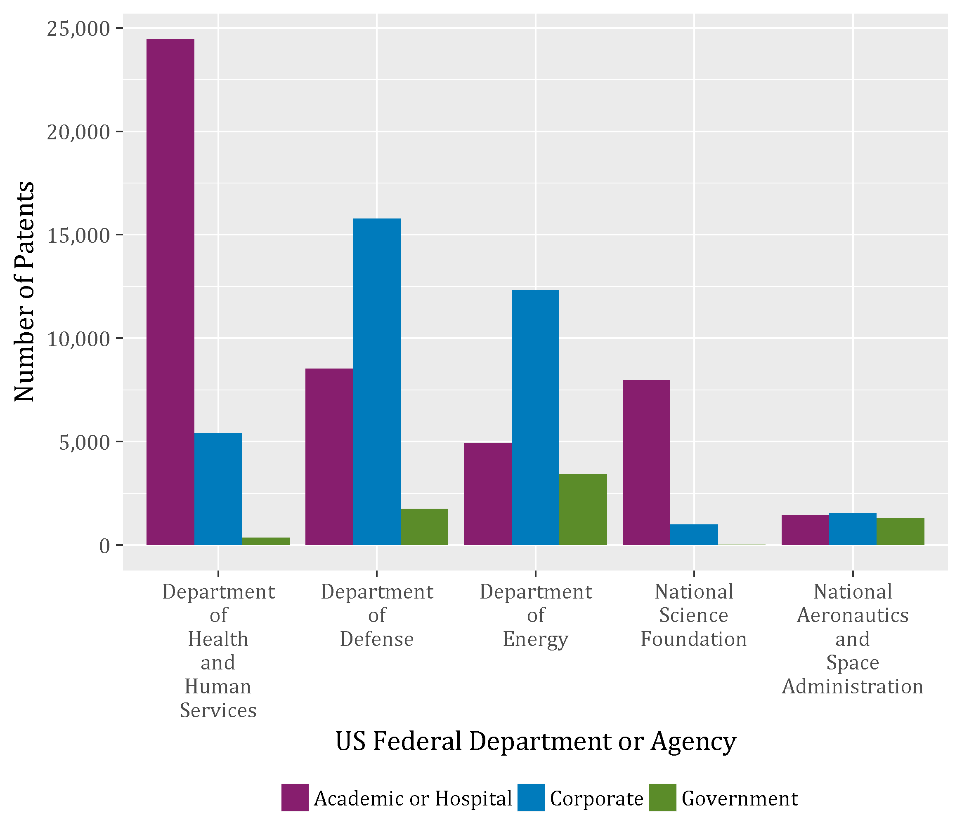

**Figure 4:** Government interest patents granted 1980-2017, top high-level federal funding agencies and assignee sectors

Perhaps unsurprisingly, the greatest shares of patents supported by DHHS and NSF funding are assigned to universities and hospitals, (81% of DHHS- and 88% of NSF-supported patents granted 1980-2017).[11] Both NSF and DHHS fund a variety of R&D projects with traditional linkages to university-based disciplines of inquiry. In the last decade, for example, DHHS supported patents assigned to academic institutions and hospitals are concentrated in biotechnology (27% of DHHS-supported patent granted 2008-2017), pharmaceuticals (20%), and organic fine chemistry (9%). DHHS-supported patents assigned to corporate entities are also largely concentrated in biotechnology and pharmaceuticals as well as medical technology. NSF-supported patents held by universities and hospitals are more evenly spread across a wide range of technologies, including computer technology (10% of NSF-supported patent granted 2008-2017), measurement (10%), biotechnology (7%), and semiconductors (6%).

Most patents supported by R&D funding from DOD and DOE are assigned to the corporate sector, including both private sector firms and privately-operated national laboratory operators[12] (60% of DOD- and 60% of DOE-supported patents granted 1980-2017). Prior literature has shown that certain areas of the federal funding R&D landscape are more amenable to applied research, where corporate firms are more active because of commercial applications.[13] In the last decade, corporately held patents funded by DOD span a wide variety of technologies, including computer technology (11% of DOD-supported patent granted 2008-2017), measurement (6%), semiconductors (5%), and engines, pumps, and turbines (4%). Likewise, DOE-supported patents held by firms are dispersed across technology categories, including electrical machinery, apparatus, and energy (10% of DOE-supported patent granted 2008-2017), measurement (7%), computer technology (7%), and engines, pumps, and turbines (6%).

Similar to DHHS, DOD, DOE, and NASA research funding span sectors. In fact, in total, DOD has supported more patents assigned to academic institutions and hospitals than NSF. Within sectors, government interest patent ownership is relatively dispersed across organizations. For the top five funding agencies, entities with the most government-supported patents include eight different universities and 11 distinct private firms and research institutes or laboratories (see Appendix C).

As Figure 4 shows, DOE supports the largest number of patents assigned within the Federal Government, though NASA and DOD fund government-held patenting as well. Overall, however, the share of government-supported patents held by the government itself is small. Figure 5 depicts trends in the composition of government interest patents by assignee sector for the entire post Bayh-Dole period. Since Bayh-Dole, the share of government interests patents assigned to a government entity has declined considerably from roughly 60% in the mid-1980s to around 10% in the past decade. In contrast, the share of government interest patents assigned to academic or hospital and corporate sectors has increased markedly. Interestingly, in the first decade after Bayh-Dole, corporate entities were granted more government-supported patents than universities and hospitals. Since the 1990s, however, the share of government interest patents held by academic institutions and hospitals has persistently exceeded the share granted to corporate organizations.

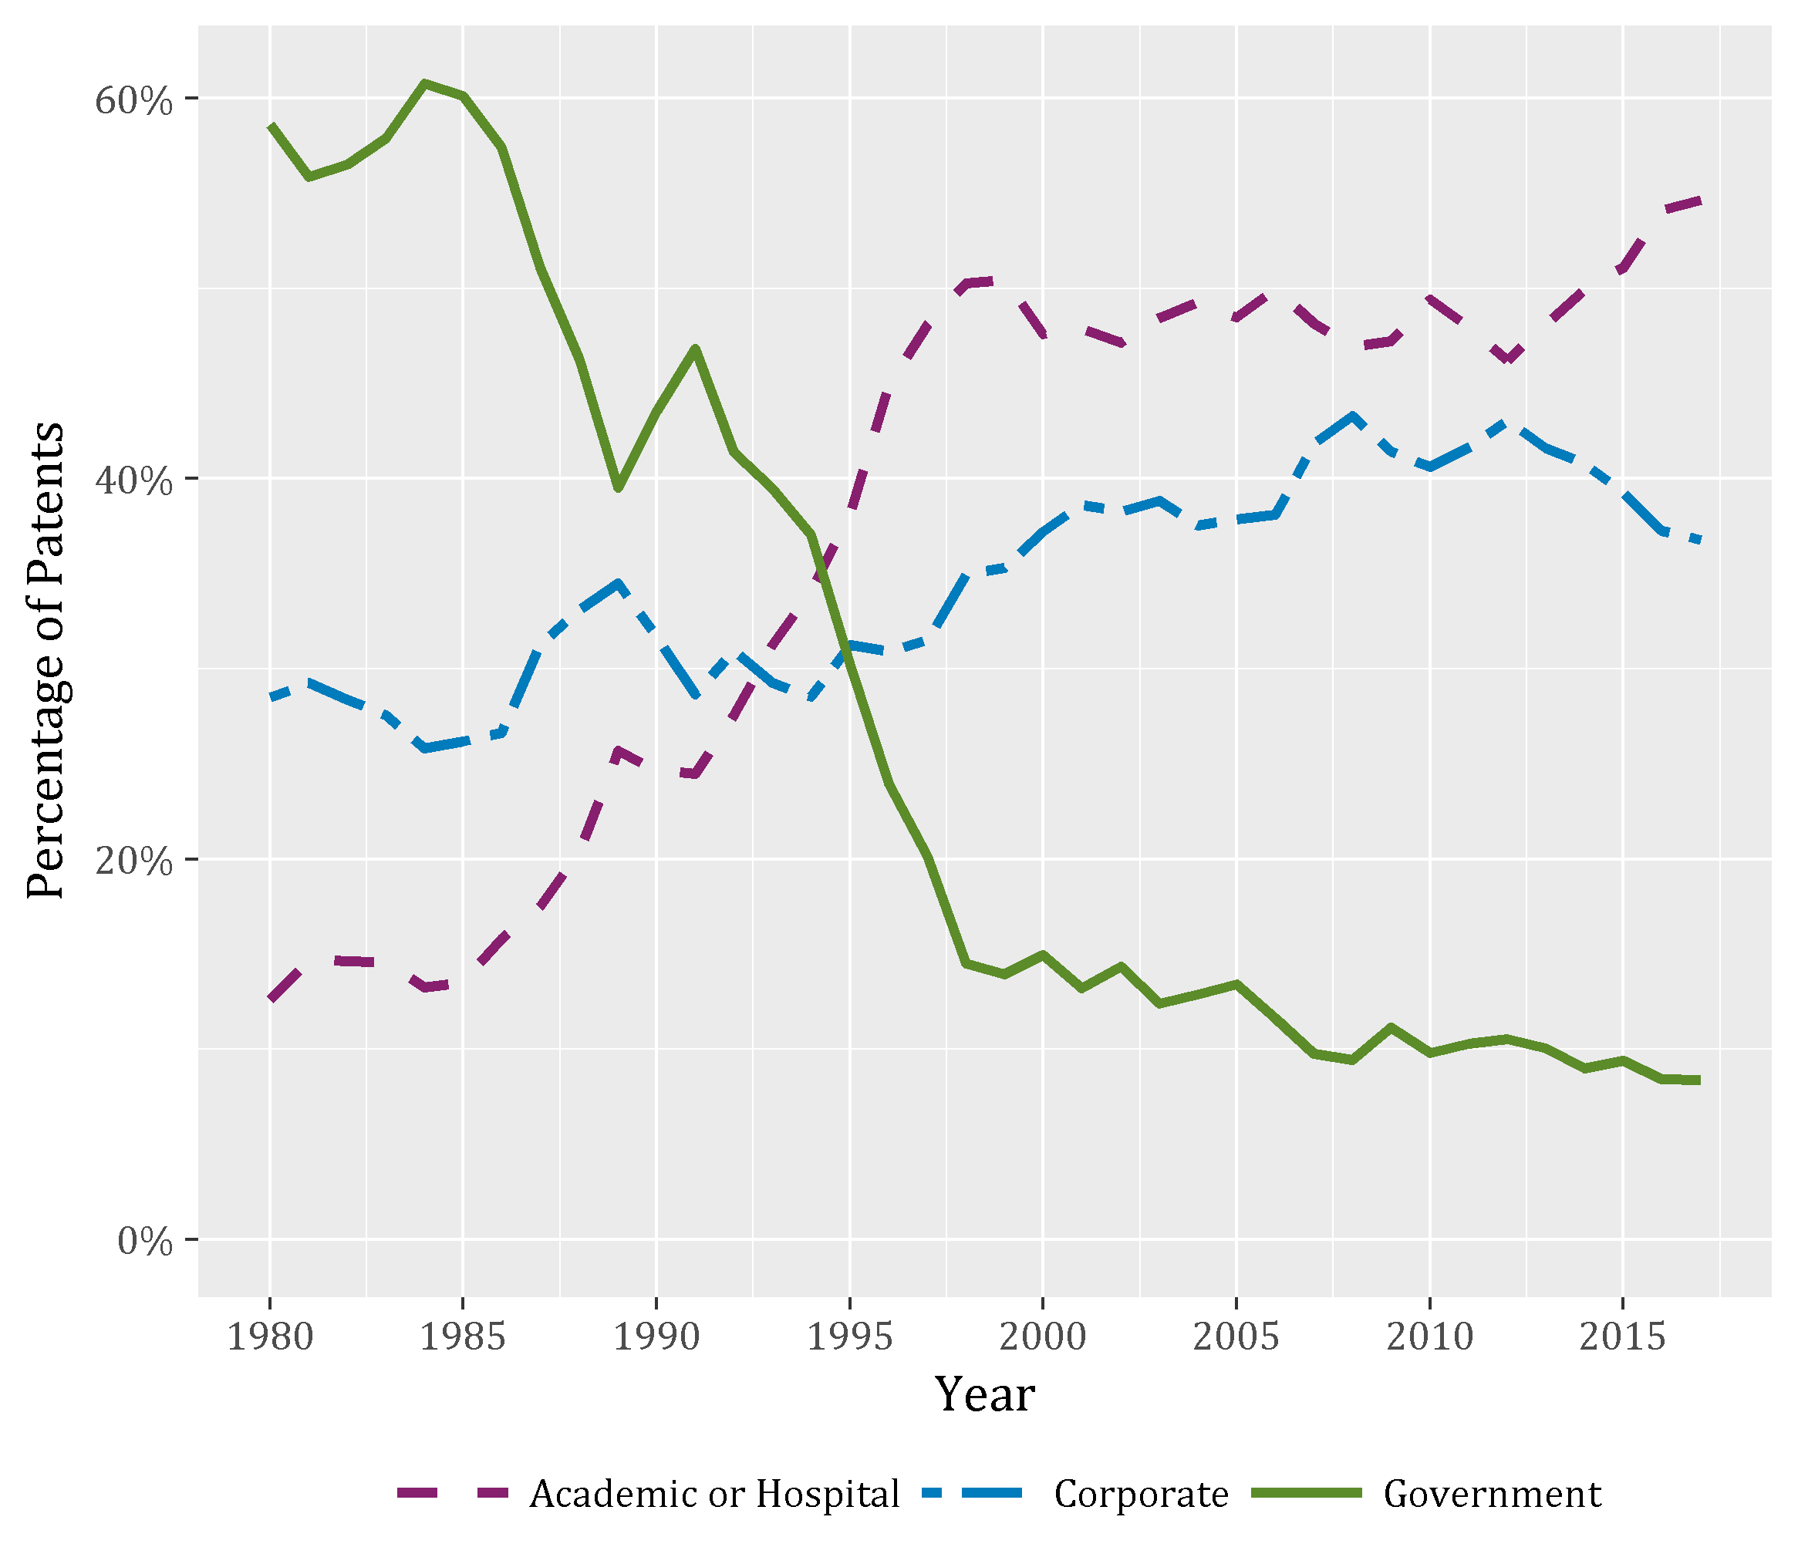

**Figure 5**: Percentage of government interest patents assigned to different sectors, 1980 – 2017

The private firms developing government-supported patents are not just large corporations. Small firms are also critical. Throughout most of the last decade, roughly one-third of corporate-held government interest patents granted were issued to small firms.[14]

Increasing intensity of technology transfer from the government to small firms, which have long been considered the engine of employment growth and disruptive innovation in the US economy. Indeed, the Federal government maintains two important programs to direct R&D funding to innovative small businesses, the Small Business Innovation Research (SBIR) program and the Small Business Technology Transfer (STTR) program.

**Government-supported patents involve expanding inventor teams**

Development of the technology protected by government interest patents often involves a team of multiple inventors. Figure 7 depicts trends in the average inventor team size for government interest patents compared to that of all patents for 1980-2017 grant years. Note that both lines are trending upward, indicating that inventor teams have been expanding over time. Prior literature has documented this trend and suggests it reflects a shift in scientific and technological production toward more collaboration among diversely specialized inventors (Jones, 2010; Jones et al., 2008; Wuchty et al., 2007).

As Figure 7 indicates, inventor teams on government interests patents have grown even larger than inventor teams overall. Starting in the early 1990s, the gap in average team size between government interest and all patents began to widen. Since 2000, government-supported patents have about one more inventor, on average, than all patents.

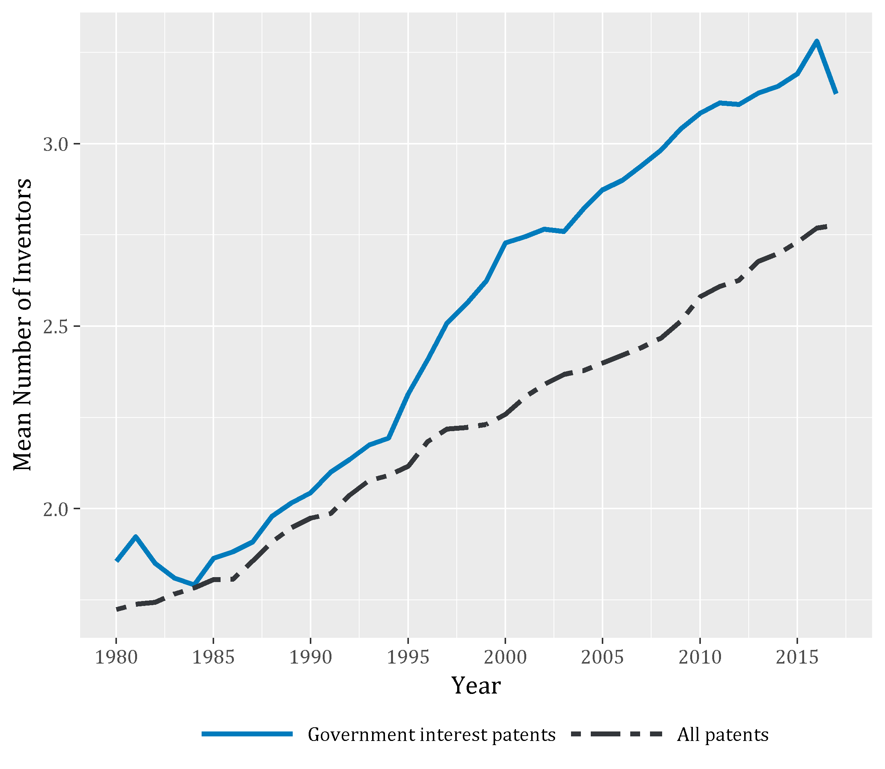

**Figure 7:** Mean number of inventors in government interest patents, and across all patents, 1980-2017

Among government interest patents, those assigned to universities or hospitals and corporate entities are likely to have more inventors than those assigned to government agencies (not shown). This can, in part, be explained by differences in technology fields. Government assigned patents are more likely to fall within measurement, optics, and other special machines technology fields, which, on average, have smaller inventor teams than fields often associated with academic and corporate patents, such as biotechnology, pharmaceuticals, and organic fine chemistry.

**A Women Inventor Contributed to Half of the Government Interest Patents Granted in Recent Years**

As government-supported patent inventor teams have expanded, women inventors are increasingly participating on those teams. Figure 8 illustrates the share of government interest patents granted with all male inventors compared to those with at least one women inventor.[15] In the Bayh-Dole era, the share of government interest patents with at least one women inventor increased fivefold from roughly 10% in 1980 to 51% in 2016. By comparison, the share of all patents with at least one women inventor grew from roughly 7% in the 1980s to only 22% in 2016 ([gender brief]).

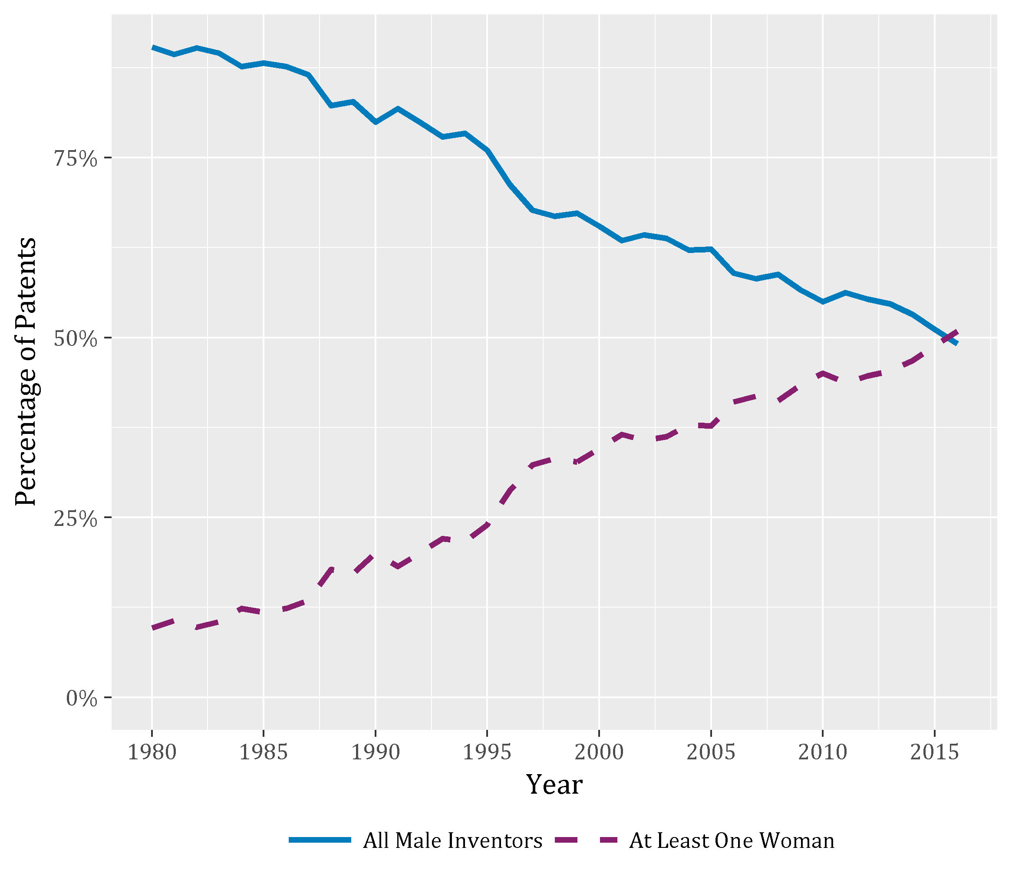

**Figure 8:** This shows a simplified version of 4b.1 without the team size component, 1980-2016

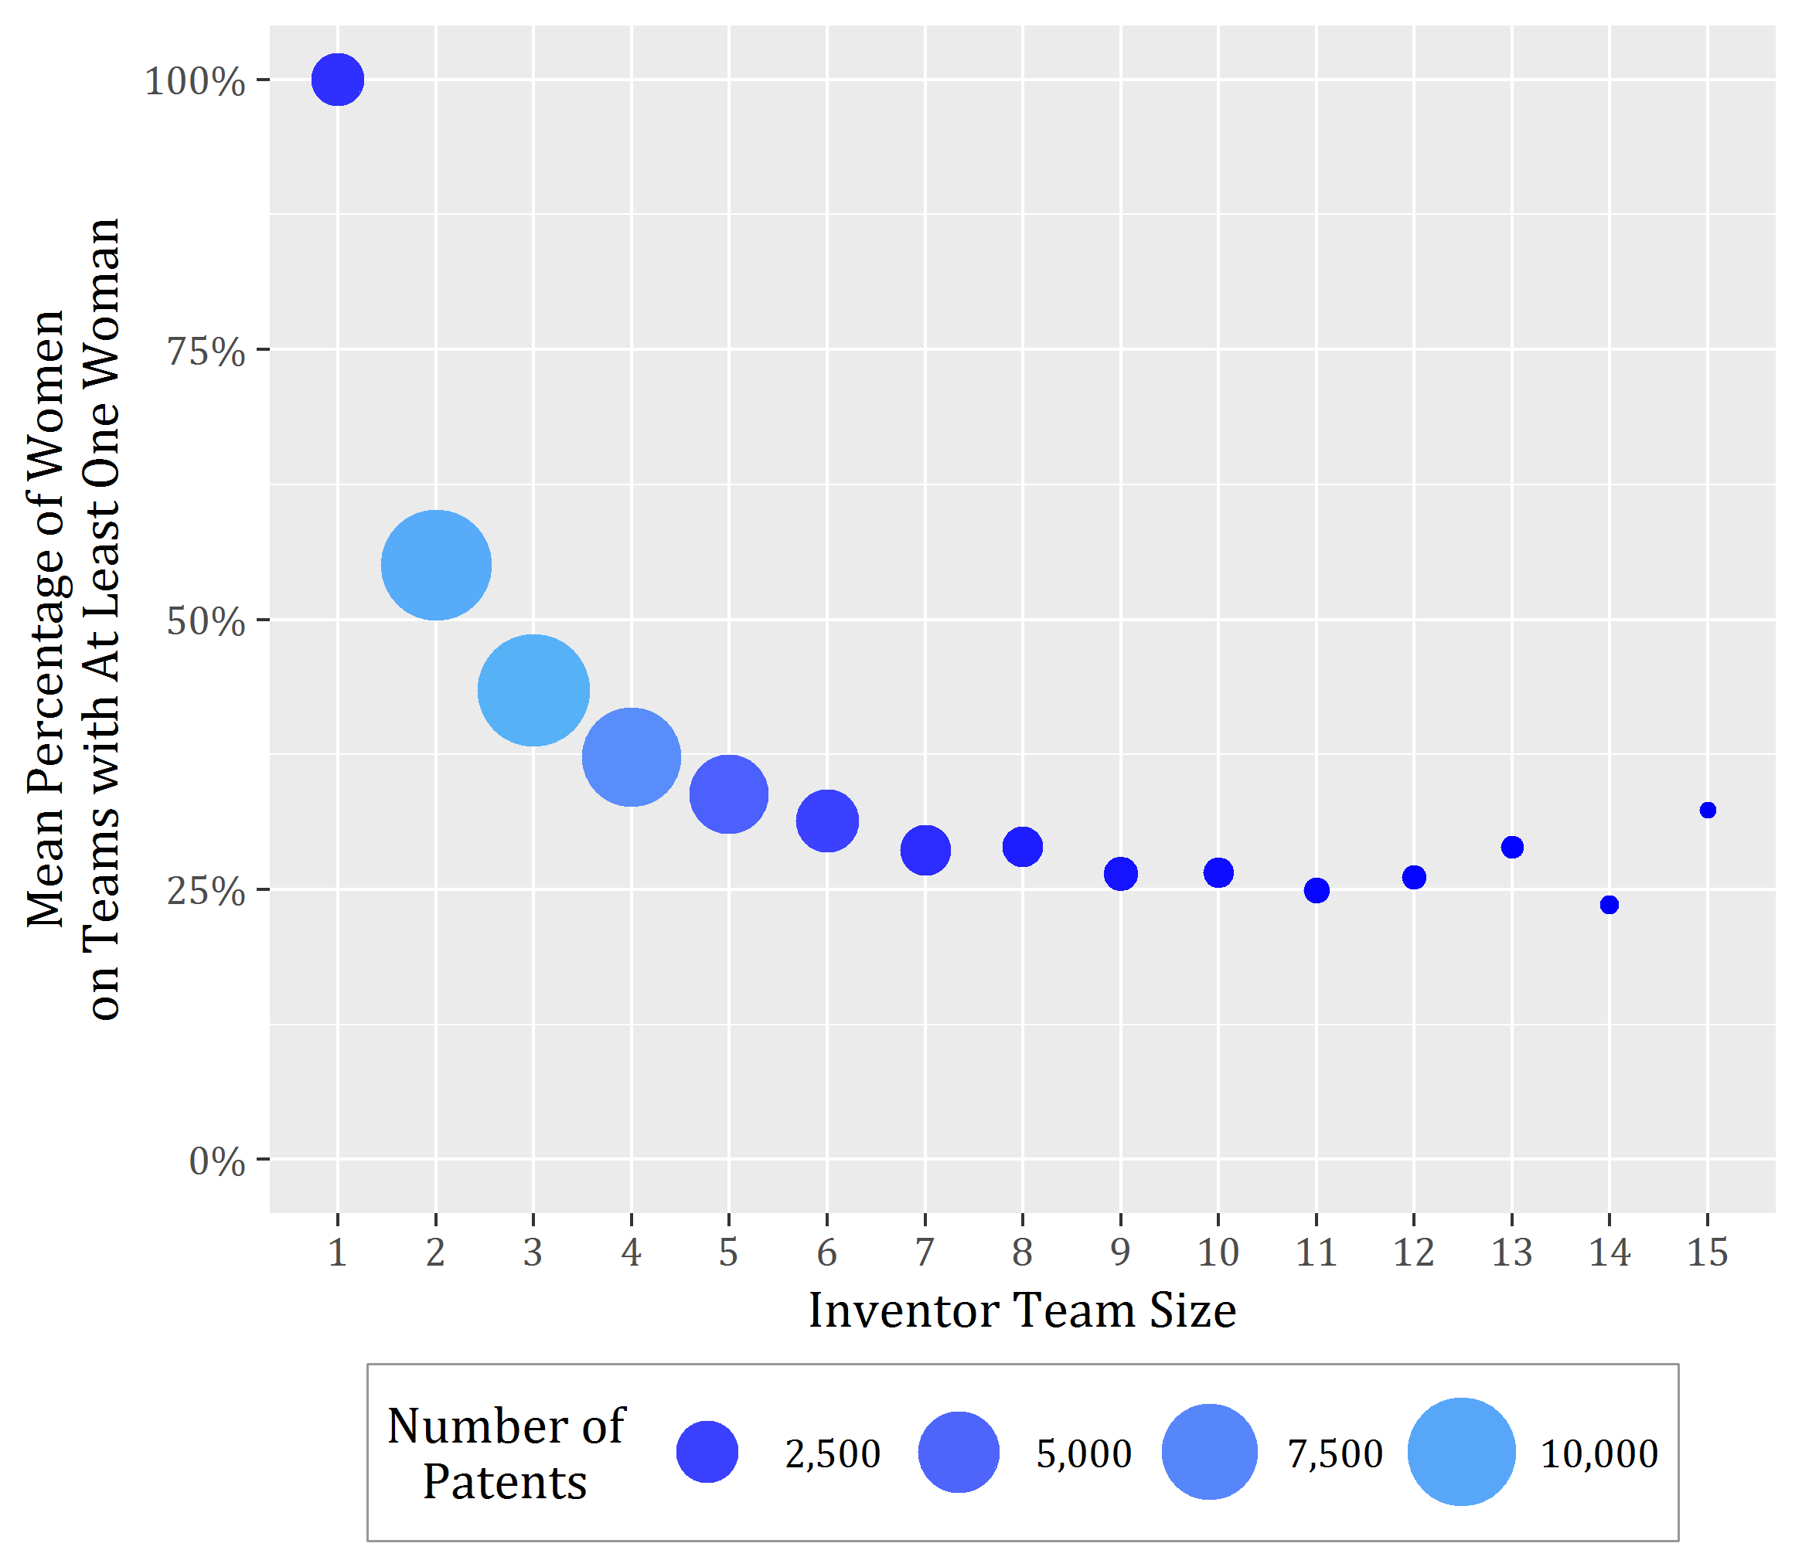

**Figure 9:** This shows a simplified version of 4b.1 without the time trend component

**Federally-support patents held by universities, hospitals, and firms are more cited than those held by government agencies**

A final takeaway relates to the impact that government interest patents have on future innovation. Figure 10 presents the average number of citations government interest patents received by subsequent patents within a five-year window from the patent grant date and broken out by the assignee sector. It includes only government interest patents granted 1980-2012, for which a full five years of citations are observable.

Government assigned patents have the lowest mean citation rate. Corporate and university assigned government interest patents have similar mean citation rates with means intersecting in 1998: this is the first year that mean five-year citation rates in corporate government interest patenting exceed those of university government interest patenting.

Figure 10 also shows that the mean citation rate for non-government interest patents (4.57 from 1980 to 2012 in the five-year citation window) exceeds the mean citation rates for corporate government interest patents (3.75), university government interest patents (3.52), and government assigned patents (2.27). Further study is needed to determine whether additional explanatory factors, such as technology class level differences, account for this overall difference in mean citation rates across government and non-government interest patents.

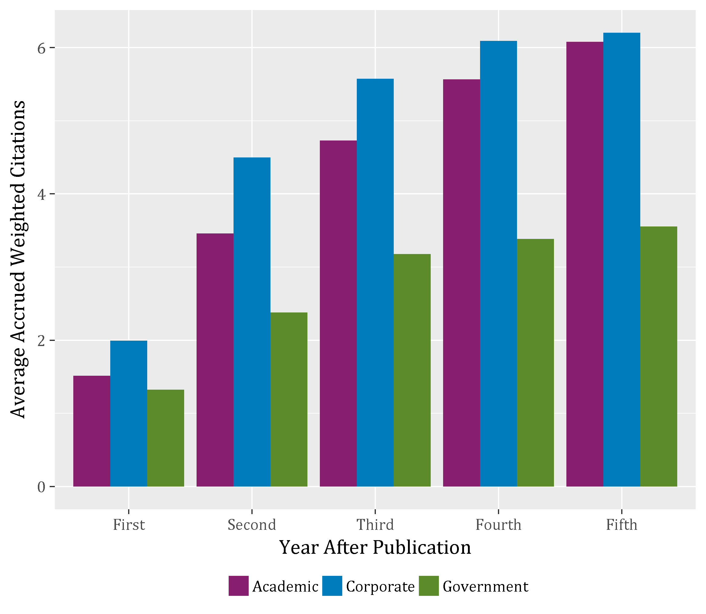

**Figure 10:** Average number of citation from subsequent patents received by government interest patents, by assignee sector, 1980 – 2012

**Appendix A: Data and Methods**

This analysis is made possible by [www.PatentsView.org](http://www.PatentsView.org), a patent data visualization and analysis platform intended to increase the value, utility, and transparency of US patent data.[16] Compared to other data sources, PatentsView affords two major advantages for studying government interest patents. First, it contains extracted and cleaned data on the US government organizations that fund government interest patents, which allows for studying trends in the source of funding over time. Second, PatentsView contains disambiguated data on inventors and patent-holding firms, universities and other entities, commonly called “assignees”. With disambiguated data, we can identify the individual inventors and assignees that have received federal R&D funding and study their productivity over time and in comparison to counterparts not receiving federal funding.

In “raw” form, the government interest statement is a plain text statement that appears on the front of the patent grant document. Box 1 provides an example of a “raw” government interest statement.[17]

**Box 1**: Raw government interest statement

This invention was made with United States Government support under Contract No. 04-03-CA-70224 awarded by the Department of Energy and Contract No. DE-AC36-08GO28308 between the United States Department of Energy and the Alliance for Sustainable Energy, LLC, the Manager and Operator of the National Renewable Energy Laboratory. The U.S. Government has certain rights in this invention.

PatentsView uses machine learning techniques to identify and extract the sponsoring government organizations and grant or contract numbers from the “raw” government interest statements. It applies Named Entity Recognition[18] to identify sponsoring organizations and a regular expression-based algorithm to identify contract and grant numbers. Box 2 illustrates the results of applying these techniques to identify organizations and contract numbers from the “raw” government interest statement in Box 1.

**Box 2**: Parsed government interest statement

The invention was made with <ORGANIZATION>United States Government</ORGANIZATION> support under Contract No. 04-03-CA-70224 awarded by the <ORGANIZATION>Department of Energy</ORGANIZATION> and Contract No. DE-AC36-08GO28308 between the <ORGANIZATION>United States Department of Energy</ORGANIZATION> and the <ORGANIZATION>Alliance for Sustainable Energy</ORGANIZATION>, <ORGANIZATION>LLC</ORGANIZATION>, the Manager and Operator of the <ORGANIZATION>National Renewable Energy Laboratory</ORGANIZATION>. The <ORGANIZATION>U.S. Government</ORGANIZATION> has certain rights in this invention.

Government Organization(s) Grant/Contract Award Number(s)

Department of Energy (DOE) 04-03-CA-70224

National Renewable Energy Laboratory (NREL) DE-AC36-08GO28308

PatentsView uses a master list of over 300 government agency name and acronym variations to distinguish the Federal government organizations from other organizations that may appear in the raw government interest statement (e.g. Alliance for Sustainable Energy, LLC). This also resolves misspellings and reconciles organization name variation and returns a single cleaned organization name (e.g. Department of Energy (DOE)) for each government entity appearing in the raw text.

Not all government-funded patents include a government interest statement. While applicants are required to include a government interest statement under Bayh-Dole, the requirement is not uniformly adopted or enforced across federal agencies or over time.[19] This may introduce some selection bias as our analysis only captures those patents for which a government interest is disclosed on the patent. Despite this limitation, PatentsView provides an accessible and high-quality source to facilitate the study of the impact of federal funding on invention outcomes.

Additionally, patents resulting from intramural R&D funding or contracts between federal agencies may not contain a government interest statement as Bayh-Dole may not apply. These “government assigned patents” result from federal R&D funding but reflect technology developed within or across agencies and provide an interesting comparison group to government interest patents. Note, however, that some patents constitute both government interest and government assigned.

Our final sample includes 114,669 government interest patents issued from 1980 to 2017.

Funding data for overall Federal R&D expenditures come from the American Association for the Advancement of Society (AAAS) at <https://www.aaas.org/page/historical-trends-federal-rd#Agency>. Federal intramural and extramural applied research expenditures and overall US applied research expenditures are sourced from NSF’s National Patterns of R&D Resources: 2014–15 Data Update available at <https://www.nsf.gov/statistics/2017/nsf17311/#chp2>.

**Appendix B: Patent growth by year**

|  |  |  |
| --- | --- | --- |
| **Year** | **All patents** | **Government interest patents** |
| 1980 | 66,212 | 1,297 |
| 1981 | 71,112 | 1,246 |
| 1982 | 63,292 | 1,202 |
| 1983 | 62,019 | 1,279 |
| 1984 | 72,689 | 1,470 |
| 1985 | 77,276 | 1,433 |
| 1986 | 77,050 | 1,466 |
| 1987 | 89,591 | 1,637 |
| 1988 | 84,449 | 1,375 |
| 1989 | 102,719 | 1,771 |
| 1990 | 99,275 | 1,617 |
| 1991 | 106,891 | 1,889 |
| 1992 | 107,540 | 2,065 |
| 1993 | 109,933 | 2,106 |
| 1994 | 113,723 | 2,246 |
| 1995 | 113,954 | 2,066 |
| 1996 | 121,811 | 2,272 |
| 1997 | 124,181 | 2,627 |
| 1998 | 163,265 | 3,332 |
| 1999 | 169,252 | 3,423 |
| 2000 | 176,192 | 3,337 |
| 2001 | 184,172 | 3,598 |
| 2002 | 184,494 | 3,685 |
| 2003 | 187,104 | 3,547 |
| 2004 | 181,413 | 3,387 |
| 2005 | 157,829 | 3,146 |
| 2006 | 196,489 | 3,841 |
| 2007 | 182,978 | 3,563 |
| 2008 | 185,260 | 3,495 |
| 2009 | 192,052 | 3,984 |
| 2010 | 244,599 | 5,340 |
| 2011 | 248,101 | 5,402 |
| 2012 | 277,285 | 6,266 |
| 2013 | 303,658 | 6,719 |
| 2014 | 327,014 | 7,095 |
| 2015 | 326,969 | 6,945 |
| 2016 | 334,674 | 6,801 |
| 2017 | 352,585 | 7,279 |
| **Average growth rate** | 5.05% | 5.34% |

**Appendix C: Top funding input to invention output flows**

The diagram below shows a detailed view of these differences by depicting 27 of the largest government interest flows, as measured in patents between government funding bodies and assignees. Large flows span between Department of Energy to prominent private sector firms operating select national laboratories. For example, National Technology and Engineering Solutions of Sandia, a Honeywell subsidiary, manages and operates Sandia National Laboratories, one of three National Nuclear Security Administration research and development laboratories. In contrast, Department of Defense funds R&D work resulting in a significant amount of patenting activity assigned to large, well-known multi-national corporations, such as IBM, Raytheon, Boeing, and Honeywell. DHHS, NSF, and NASA’s largest funding flows to universities, many of which have large medical and pharmaceutical research schools. Interestingly, the University of California System, which includes 10 campuses and 3 national laboratories, is a top assignee for DoE, NSF, DoD, and DHHS. MIT, on the other hand, is top assignee for NSF, DoD, and DHHS. Finally, while NASA is more likely to fund R&D resulting in private sector patenting than university patenting, the California Institute of Technology is a top NASA assignee; Caltech runs NASA’s Jet Propulsion Laboratory, a federally funded R&D center located in Pasadena, California.

**Figure A**: Top government interest to assignee patenting flows, 1980-2017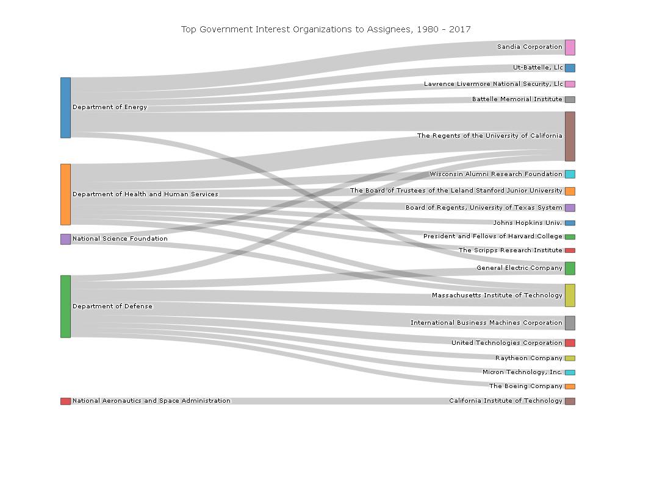

1. The Patent and Trademark Law Amendments Act, more commonly called the Bayh-Dole Act, permits universities, small businesses, and nonprofit organizations to elect to retain ownership of inventions developed under federally-funded contracts, grants, or cooperative agreements. 35 U.S.C. § 202. The Federal Government, in turn, retains a nonexclusive, irrevocable, and free license to utilize the patented technology. 35 U.S.C. § 202(c)(4); 37 C.F.R. § 401.14(b)
2. 35 U.S.C. § 202(c)(6). Federal regulations further require the organization to include, within the specification of any U.S. patent application and any patent issuing thereon, the following statement “This invention was made with government support under (identify the contract award) awarded by (identify the agency). The government has certain rights in the invention.” 37 C.F.R. § 401.14)(f)(4).
3. 2016 Federal R&D funding was imputed using Bureau of Economic Analysis deflators.
4. *Sources*: PatentsView and the American Association for the Advancement of Science. Retrieved from <https://www.aaas.org/page/historical-trends-federal-rd#Agency> on January 5, 2018.
5. [Table 2 in Appendix shows the proportion of all government interest patents for all technology fields.]
6. *Sources*: PatentsView and the American Association for the Advancement of Science. Retrieved from <https://www.aaas.org/page/historical-trends-federal-rd#Agency> on January 5, 2018.
7. [Definition of high-level agency]
8. [These five agencies accounted for 80-84% of government interest patents granted in each year 2012-2016]
9. In 2015, DHHS funded approximately $31.7 billion in research grants and other contracts, with $29.2 billion accounted for by the NIH.
10. [DOE provided funding for or had an interest in 15-17% of government interest patents granted in each year 2012-2016]
11. In 2015, DHHS distributed $16.2 billion in R&D to universities and colleges. NSF, on the other hand, had a smaller annual research budget of $6.1 billion, of which $4.6 billion went to universities. *Sources*: American Association for the Advancement of Science. Retrieved from <https://www.aaas.org/page/historical-trends-federal-rd#Agency> on January 5, 2018.

    National Science Foundation. Retrieved from <https://ncsesdata.nsf.gov/fedsupport/2015/html/FSS2015_DST_19.html>
12. All but one of the 17 national laboratories associated with the DOE are managed and operated by private-sector organizations. These 16 labs are classified as corporate assignees in Figure 4.
13. Hughes, M.E., et al. (2011). “Technology Transfer and Commercialization Landscape of the Federal Laboratories.” *NS P-4728. Institute for the Defense Analyses, Washington, DC.*

    Vetterkind, M. (2017). Agency Budgets: Chapter 11: Department of Defense. Retrieved from <https://www.aaas.org/fy16budget/department-defense>
14. A patent is designated as issued to a small firm if it received a small or micro entity (2013 grants and after) discount on the patent issuance fee. Roughly, 31-37% of government interest patents granted in each year 2008-2017 and assigned to corporate entities received a small or micro entity discount on the patent issuance fee.
15. Data on inventor gender from [source] only available for government interest patents granted 1980-2016.
16. The [www.PatentsView.org](http://www.PatentsView.org) initiative is supported by the Office of Chief Economist in the US Patent & Trademark Office (USPTO).
17. Figure 1 & Figure 2 example from US 7897396 <http://www.patentsview.org/web/#detail/patent/7897396>
18. Jenny Rose Finkel, Trond Grenager, and Christopher Manning. 2005. Incorporating Non-local Information into Information Extraction Systems by Gibbs Sampling. *Proceedings of the 43nd Annual Meeting of the Association for Computational Linguistics (ACL 2005),* pp. 363-370. <http://nlp.stanford.edu/~manning/papers/gibbscrf3.pdf>.
19. *See, e.g.,* Arti K. Rai & Bhaven N. Sampat, Accountability in Patenting of Federally Funded Research, 30 NATURE BIOTECH. 953 (2012). This study finds evidence of underreporting though improvement in compliance over time. Using data on patents recorded in National Institutes of Health (NIH) RePORTER (and accordingly developed with NIH funding), they find that 20-40% of grant year cohorts 1981-2007 had no government interest disclosed on the front of the patent. The study does show the incidence of a government interest rate increasing over time to 90% for patents issued in 2007.